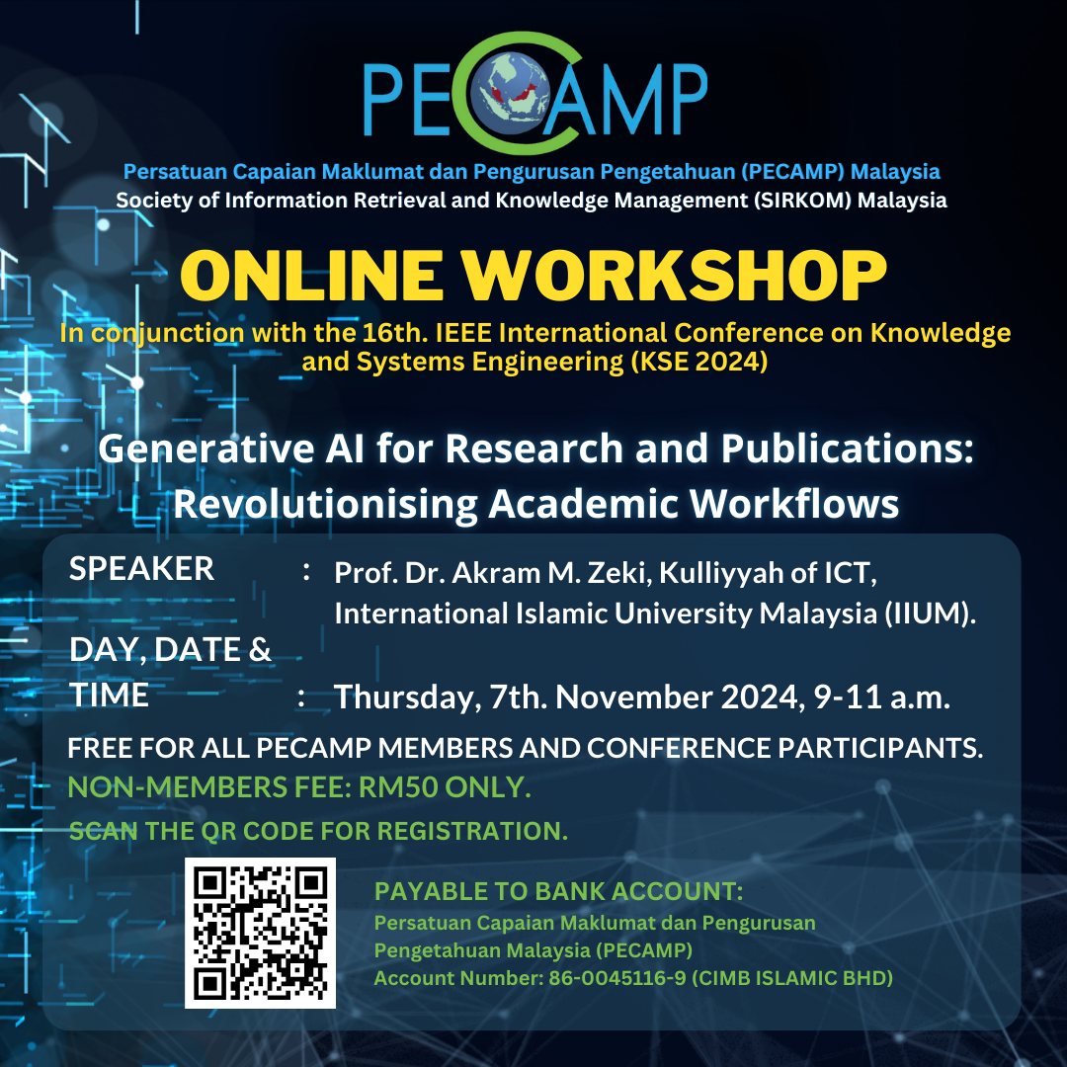

Online Workshop Title | : | Generative AI for Research and Publications: Revolutionizing Academic Workflows
Abstract and Objectives | : | The upcoming workshop, "Generative AI for Research and Publications: Revolutionizing Academic Workflows", will explore how cutting-edge AI technologies are reshaping the research landscape. Participants will be introduced to the fundamentals of Generative AI, understanding its distinction from traditional AI, and discovering its potential for automating and enhancing various stages of the research process. Through practical demonstrations of AI tools like ChatGPT, Consensus, and QuillBot, attendees will learn how to streamline tasks such as literature reviews, data analysis, and academic writing. The workshop will also address key ethical considerations, ensuring participants understand the importance of responsible AI usage in academia.  Objectives:  - To provide an overview of generative AI and its impact on the research and publication processes.  - To demonstrate AI-powered tools for enhancing research efficiency, including literature review, writing, and data interpretation.  - To show how AI can assist at different stages of research, from experiment design to collaboration and publication.  - To discuss the ethical responsibilities researchers must consider when utilizing AI technologies in their work.  - To offer strategies for integrating AI into daily academic tasks to boost productivity and optimize research outcomes.  Outcome:  This workshop is designed to empower researchers, academics, and students to leverage AI tools, enabling them to enhance the quality and efficiency of their work while remaining mindful of ethical practices.
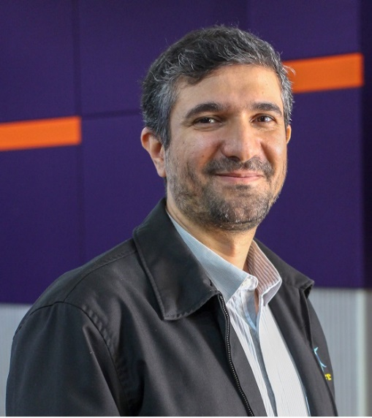 |  | Dr. Akram Mohammed Zeki is a Professor at Faculty (Kulliyyah) of Information and Communication Technology at International Islamic University Malaysia. He held few administration positions such as Coordinator for Postgraduate Studies at Faculty (Kulliyyah) of Information and Communication Technology, and then Head of Research in the same faculty and then held a position as a Deputy Director of CENTRIS and Acting Director as well.  He is a supervisor for more than 30 master and PhD students; he is leading few research grants under the university (International Islamic University Malaysia) or under national grants and international grants.  Professor. Dr. Akram has more than 155 publications in Scopus. Beside that he received few awards from university and national level.  His research interest including Information Security, Image Processing & Multimedia, as well as Computer Ethics and ICT & Islam.

