*(10pt space)*

*(10pt space)*

**Title of abstract in Times New Roman; Title Case, Font: size 20 points; Centred paragraph; 2 lines only**

*(10pt space)*

*(10pt space)*

1Author *, 2Author , 3Author , 4Author , 5Author *(Max 5 names only, Font Times New Roman, 10 pt, Align -Centred)*

*\*Lead presenter/ Corresponding author*

*e-mail address of lead presenter, Institution, country*

*2Institution, country*

*3Institution, country*

*4Institution, country*

*5Institution, country*

*(10pt space)*

*(10pt space)*

**ABSTRACT**

*(Font Times New Roman, Capital Letter, Text Bold, 12pt, Align Centred)*

*(11pt space)*

The main text, like the author names, uses Times New Roman font, 10 points for the Author names (maximum 5 names) and 11 points for the remainder of the abstract. Type or paste your text into this file, but remember to keep the page margins the same as is set here which is 1 inch or 2.5 cm all round. Paragraphs are justified (straight-edged) on both left and right. Use single-line spacing and leave a line gap between paragraphs. This helps your text to be read easily. If you would like to insert a figure you can do so. Use the insert picture command and paste special as an enhanced metafile for ease of handling. If you want, you can set the text to flow around the figure, but do remember to include a figure caption. Abstract deadline: 1 November 2024; Abstract Acceptance Notification: 10 November 2024; Full Paper Deadline: 30 November 2024; Acceptance Notification: 30 December 2024; Camera-ready Paper Deadline: 30 January 2025; Early Bird Deadline: 30 December 2024. If you need to receive a formal acceptance of your abstract in order to be funded to come to the conference, please write this in your email when you submit your abstract and you will receive a prompt reply. The organisers expect that there will be more abstracts submitted with preference for oral presentation than can be accommodated in the programme. The limit for your abstract is **300 words**. Abstracts that do not meet these formatting requirements will be returned. The organising committee reserves the right to edit abstracts for clarity or correctness of English, but will consult the author if any significant changes are needed. *(Font Times New Roman, Regular, 11pt, Align Justified)*

*(11pt space)*

**Keywords: Keyword 1, Keyword 2, Keyword 3 (Min 3 key words & Max 5 Key words)** *(Font Times New Roman, Bold, 11pt, Align Justified)*

*(11pt space)*

*(11pt space)*

# INTRODUCTION

*(11pt space)*

This format is to be used for submissions to CASSIC’25. We wish to give this conference a consistent, high-quality appearance. We, therefore, ask that authors follow some simple guidelines. In essence, you should format your paper exactly like this document. The easiest way to do this is simply to download a template from the conference website and replace the content with your own material.

*(11pt space)*

The full paper should be written in MS Word format in single-spaced 11 point Times New Roman. Do not indent the text paragraphs. Please briefly explain the aim and scope of the study, the materials and methods, and the main findings and brief analysis of the study. You can add sections as you wish, following the section heading format as shown in this section. Please observe Figure 1 and Table 1 to include figures and tables in the full paper, respectively.

*(11pt space)*

Authors are requested to submit the full paper **(Min 10 - Max 15 pages in the length including references)** in electronic form (MS-Word) via our Online Submission. Incorrect formatting may result in your paper being returned to you by email. The committee will select the manuscript for oral and poster presentations.

*(11pt space)*

Following the conference, all accepted papers will be published in the CASSIC’25 proceedings. Additionally, selected papers will be featured in indexed journals or proceedings, subject to editorial review and approval.

*(11pt space)*

*(11pt space)*

**LITERATURE REVIEW**

*(11pt space)*

A literature review is a comprehensive summary and analysis of existing research on a specific topic. It involves identifying, evaluating, and synthesising previous studies, theories, and arguments in the field. Literature reviews are typically found in research papers, theses, dissertations, and reports, helping to frame the research question and methodology.

*(11pt space)*

*(11pt space)*

**METHODOLOGY**

*(11pt space)*

Methodology refers to the systematic plan or approach used in research to collect, analyze, and interpret data. It outlines the specific methods, techniques, and procedures the researcher follows to investigate a particular problem or question. Methodology not only explains **how** the research is conducted but also justifies why certain methods are chosen over others.

*(11pt space)*

*(11pt space)*

**ANALYSIS & RESULTS**

Figures can be included in your full paper and referred to in the text.

*(11pt space)*

**Figures & Tables**

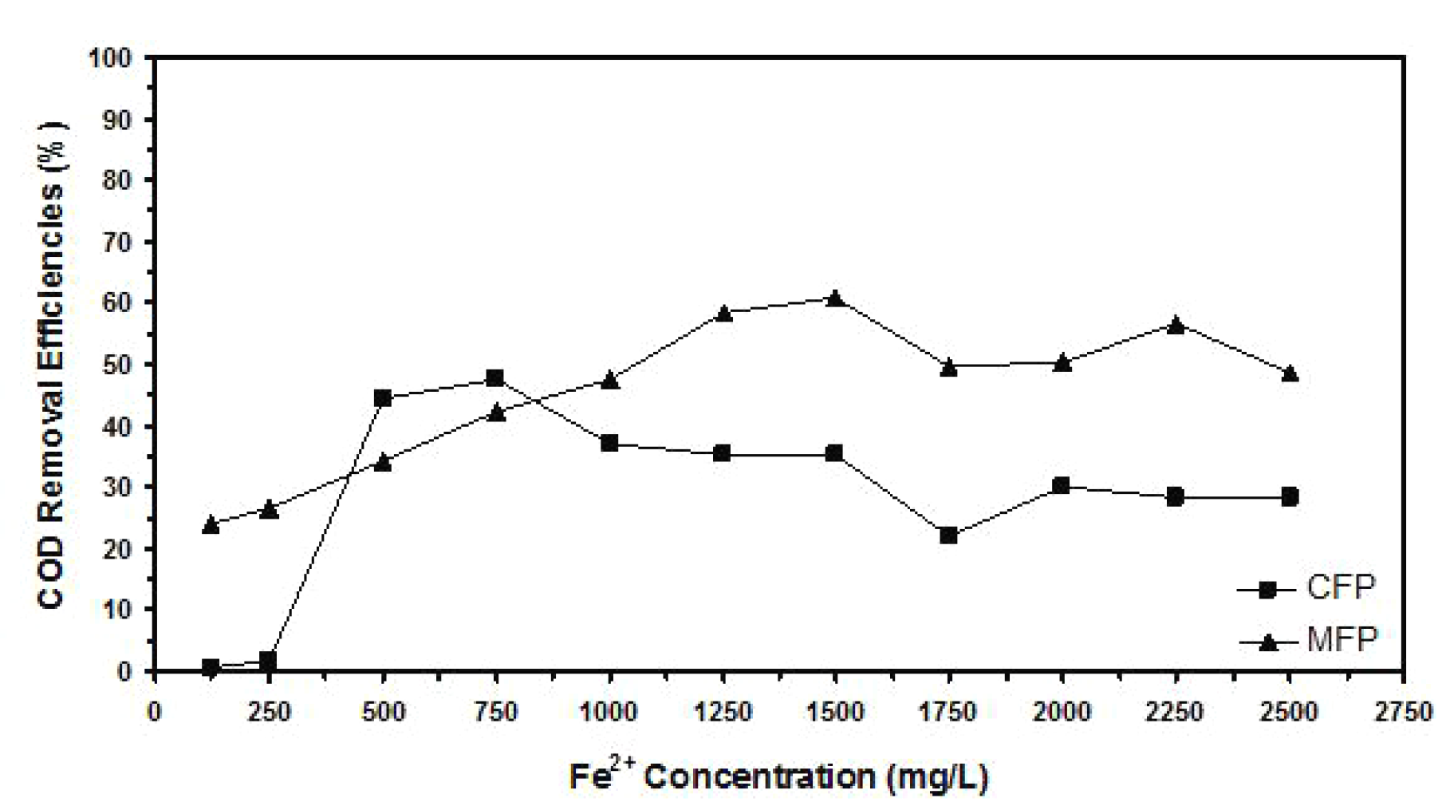

**Figure 1.** Example of a figure caption.

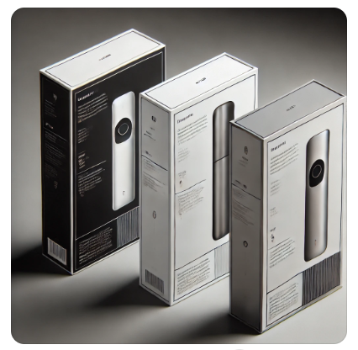

**Figure 2. Example of a figure caption.**

*(Source:xxxx)*

*(11pt space)*

*(11pt space)*

A table should be inserted like the one below and referred to in the text.

*(11pt space)*

**Table 1. Example of a table caption**

| **No** | **Contents** |
| --- | --- |
|  |  |

*(11pt space)*

*(11pt space)*

**CONCLUSION**

*(11pt space)*

The conclusion is intended to help the reader understand why your research should matter to them after they have finished reading the paper. A conclusion is not merely a summary of the main topics covered or a re-statement of your research problem but a synthesis of key points and, if applicable, where you recommend new areas for future research.

*(11pt space)*

*(11pt space)*

**Acknowledgment:** The authors would like to express their appreciation for the support of the sponsors with Project No xxxx.

*(11pt space)*

*(11pt space)*

# REFERENCES (min 10 - max 30 references)

*(11pt space)*

1. Abu, A. B., & Zakaria, B. (2013). Title of the manuscript in journal. Applied Materials and Mechanics, 185, 517–521..
2. Klemmer, R. S., Thomsen, M., Phelps-Goodman, E., Lee, R., & Landay, J. A. (2002). Where do web sites come from? Capturing and interacting with design history. In Proceedings of the CHI 2002 (pp. 1–8). ACM Press.
3. Schwartz, M. (1995). Guidelines for bias-free writing. Indiana University Press.
4. Choo, S. M. (2012). Title of a master’s or PhD thesis (Ph.D. thesis). Universiti Teknologi Malaysia.