THE IMPACTS OF GOODS AND SERVICES TAX (GST) ON MIDDLE INCOME EARNERS

Author Name¹*, Author Name², Author Name¹
¹School of Biological Sciences, Faculty of Applied Sciences, Universiti Teknologi MARA, Cawangan Negeri Sembilan, Kampus Kuala Pilah, 72000 Kuala Pilah, Negeri Sembilan, Malaysia
²School of Chemistry and Environment, Faculty of Applied Sciences, Universiti Teknologi MARA, Cawangan Negeri Sembilan, Kampus Kuala Pilah, 72000 Kuala Pilah, Negeri Sembilan, Malaysia

*Corresponding author: james.smith@gmail.com

ABSTRACT

This template provides formatting guidelines for biomasauthors in the preparation of manuscript for publication. The authors must strictly follow the instructions given in this template for their manuscript preparation.

[Maximum number of words for abstract is 300. Use Times New Roman, 12-point font with text justified and single-spacing paragraph]

Keywords: abstract, maximum, five, [maximum 5, Times New Roman, font size 12 and text position left. Leave ONE blank line after abstract]

INTRODUCTION

This template provides formatting guidelines for authors in the preparation of manuscript for publication. The authors must strictly follow the instructions given in this template for their manuscript preparation. The Introduction section should contain background about the research, problem statement, significance of the research and do mention the originality/novelty of your research. It is not advisable to use subsections such as ‘Literature review’, ‘Research Questions’ and etc.

METHODS

Study Area [Second order headings should be bold, Times New Roman, 12 point font, unindented, left justified]

This template provides formatting guidelines for authors in the preparation of manuscript for publication. The authors must strictly follow the instructions given in this template for their manuscript preparation. All abbreviated forms should be spelled out for the first time. Use equation editor for all mathematics formulaes.

RESULT AND DISCUSSION
This template provides formatting guidelines for authors in the preparation of manuscript for publication. The authors must strictly follow the instructions given in this template for their manuscript preparation. All abbreviated forms should be spelled out for the first time. Use equation editor for all mathematics formulaes.

NOTE: The tables and figures should be followed by the text!

Table 1: Independent samples T-test between gender and readiness, perceptions and acceptance of GST

 | t | df | Mean Difference | Std. Error Difference
READY | 24.479 | 38 | 3.19658 | .21850
PERCEPT | 38.833 | 38 | 3.42735 | .16249
ACCEPT | 44.328 | 38 | 3.26496 | .12332
BEHAVIOUR | 45.542 | 38 | 3.22121 | .12211

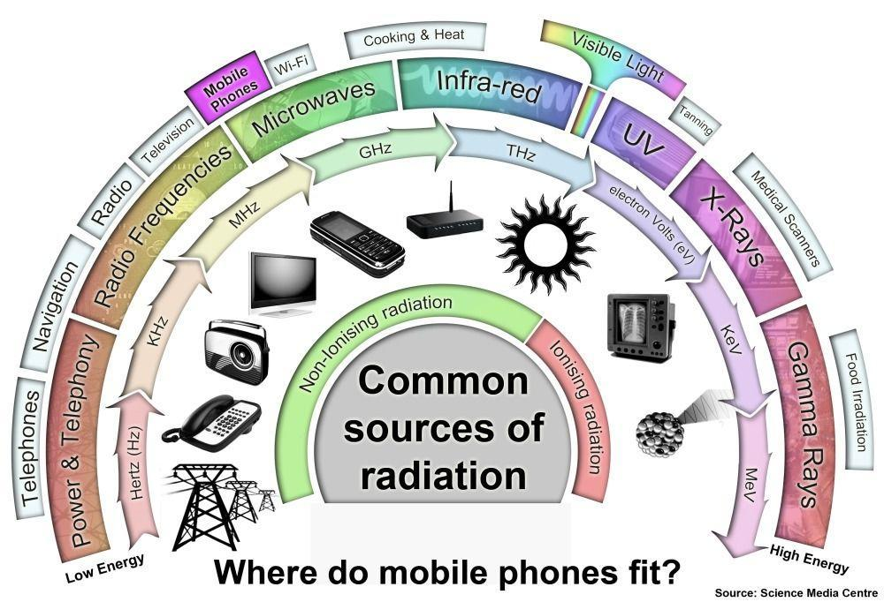
Figure 1. Common sources of radiation

CONCLUSION
This template provides formatting guidelines for authors in the preparation of manuscript for publication.

REFERENCES
[References should be listed in alphabetical order, Times New Roman, font size 12, justified and single-spacing paragraph with format:
Journal – Authors. (Years). Title of paper. Journal title (spelled full), Volume (Issue number-optional), pages. DOI (optional) (Use: APA format system)
Eising, M., Cava, C. E., Salvatierra, R. V., Zarbin, A. J. G., & Roman, L. S. (2017). Doping effect on self-assembled films of polyaniline and carbon nanotube applied as ammonia gas sensor. Sensors and Actuators, B: Chemical, 245, 25–33. https://doi.org/10.1016/j.snb.2017.01.132
Sambasevam, K. P., Mohamad, S., & Phang, S.-W. (2015). Effect of dopant concentration on polyaniline for hydrazine detection. Materials Science in Semiconductor Processing, 33, 24–31. https://doi.org/10.1016/j.mssp.2015.01.008

Book – Authors, years, book title. publisher name, country. volume (issue number): pages.
Alley, E. R. (2007). Water quality control handbook. McGraw-Hill, New York: pp. 2 – 3.

Kleter, G. A., & Noordam, M. Y. (2015). Safety Assessment of Genetically Modified Foods. In Advances in Food Biotechnology. Chichester, UK: John Wiley & Sons Ltd.: pp. 27–36 https://doi.org/10.1002/9781118864463.ch03

Thesis – author, years, thesis title, degree, and university
Soukaina, R. (2015). Synthesis, characterization, and electrochemical properties of polyaniline thin films, Graduate Theses and Dissertations, University of South Florida

Mottaghitalab, V. (2006). Development and characterisation of polyaniline - carbon nanotube conducting composite fibres. Retrieved from http://ro.uow.edu.au/theses/491

Webpage – author or institution, year, title, link website, date access [The web url based references shouldn’t be more than 10% of total references]
Ministry of Health (2010). Effect of e-ciagrettes. http://www.e-cig.com.gov.my/list/. [Access online 24 August 2017].

