**POSTER PRESENTATION FORMAT**

*Assalamualaikum WBT* and greetings.

Dear all poster presenters.

Thank you for your participation as poster presenters in The International Conference on Halal and Fatwa (ICCoHaF) 2024.

You are requested to fulfill with the poster presentation format as below:

**Specifications for Poster Presentations**

* Poster displays will be limited to one side of an A2 sized Canvas board (42cm x 52.4cm).
* Oversized posters will obscure an adjacent poster and will be rejected. Computer display equipment, sound or projection equipment, or freestanding displays are not permitted.
* The conference staff will provide stands for the posters
* All posters must be set up in the time allotted before the session and must remain up until the session ends. Presenters are to remain by their poster during the entire time of the assigned session time, to answer questions and be evaluated by poster judges.
* After the session ends, posters and materials should be promptly removed and the area cleaned up.
* Be sure to include the research/abstract title, author and coauthor names, and the institution(s) where research is underway.
* Place your correspondence’s name, e-mail address and phone number at the bottom of the poster.
* It is recommended that you hand-carry your poster to the conference, using tubular packaging or a portfolio case.

**Criteria for Judging Poster Presentations**

* Given the number of posters, judges may only have less than 10 minutes to review, discuss, and evaluate a poster presentation.
* Poster presentation will be evaluated based on the following criteria:

1. Quality and relevance of the abstract.
2. Content and layout of the poster: (a) The title, names of authors, and the institution(s) where the research was performed should be included at the top of the poster. (b) Poster layout and template should be in a logical order, including text and graphics that explain the objectives of the research and why the research is important; methods and controls; findings/results; conclusions and future research; and references.

* Presentation: Presenters should demonstrate a good understanding of the study and related areas and responds effectively and clearly to questions.

**Tips for Poster Preparation**

* Posters should stimulate discussion, not give a long presentation. Therefore, keep text to a minimum, emphasize graphics, and make sure every item included in your poster is necessary.
* Utilize handouts to supplement your poster (if necessary).
* Make sure ideas flow logically from one section to the next.
* Use charts and graphs to illustrate data (avoid large tables of raw data).
* Use high-resolution photographs (web images often will not work).
* Do not use all capital letters.
* Be consistent: Keep consistent margins, keep line spacing consistent, keep the color, style, and thickness of borders the same, keep shading consistent, pick no more than 3 fonts, and pick no more than 2–3 colors.

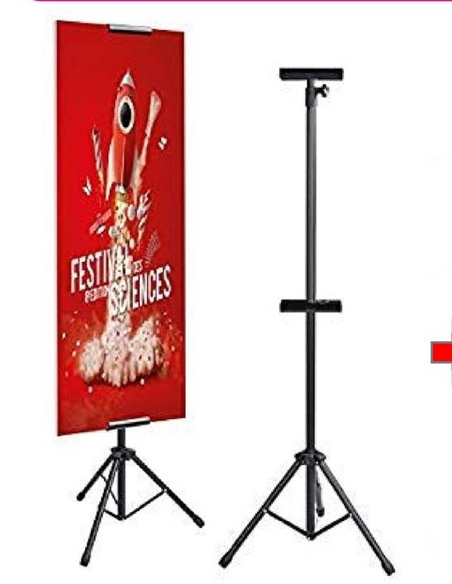

TRIPOD STAND WHICH WILL BE PREPARED FOR THE CANVAS POSTER

(SIZE A2-43CM X 52.4CM)