**Title: Kedah Heritage Sites: Research From The Archaeotourism Aspect And The Environmental Influence** (Times New Roman/TNR 14pt, bold)

Author: First name1, second name2, Third name1 (TNR, 12pt, regular)

**1Fakulti of Social Science, Universiti Pendidikan Sultan Idris, 35900 Tanjong Malim, Perak Malaysia**

**2Fakulti of Sains Sosial, Universiti Melaka (UNIMEL), 78200 Kuala Sungai Baru, Melaka, Malaysia**

(Name of the institution, TNR, 12pt, bold)

**[xxxxx@yahoo.com](mailto:xxxxx@yahoo.com), [xxxxx@unimel.edu.my](mailto:xxxxx@unimel.edu.my), [xxxxx@fsk.upsi.edu.my](mailto:xxxxx@fsk.upsi.edu.my).**

(official email of the institution, TNR, 12pt, regular)

ABSTRACT (12pt, bold)

The study of heritage sites in Kedah began around the 1840s in the Bujang Valley until now. Various types of heritage sites especially archaeological sites are found around the Bujang Valley, particularly in Pengkalan Bujang, Sungai Mas and Sungai Batu. The definition of Bujang Valley includes the area from Sungai Sala in the North, Gunung Jerai, Sungai Merbok Valley and Sungai Muda to Cherok Tokkun. This situation contributes to the research on archaeotourism because it has a great impact on the local community and the country in particular. The research method used in this study are field research and library research. Field research was done by carrying out an observation in the area involved. Meanwhile, library research involved searching for primary sources by referring to excavation reports by the National Heritage Department as well as written reports found in the National Museum Library and some public universities. The research heritage sites involved sites that were frequently visited by both local and foreign tourists. The results of the study found that environmental factors play an important role in contributing to the increase in tourist arrivals that attract tourism interest in archaeotourism in the Bujang Valley. This paper explains the archaeotourism aspect that can be adapted through the discovery of Kedah heritage sites in the Bujang Valley and focuses at the environmental factors that contribute to the discovery of Kedah heritage sites.

(Abstract not more 250 words)

Article in Malay and Arab words must write abstract in English)

Keywords –Heritage Site, Bujang Valley, Archeology, Archaeotourism, Environmental Influence

Introduction ( every title or subtitle :TNR, 12pt, Bold, Capitalize)

1. Paragraph (Times New Roman (TNR), 12pt, line spacing 1.5)

2. Empirical based article

(In general, the contents should comprise of Introduction, Methods, Results and Discussion, Conclusion and References)

3. Illustrations and tables

Illustrations and tables should supplement the text and not duplicate it. Each table should have a title, centered at the top of the table, that is proceeded by the word TABLE and its number (use normal numerals). Notes to a table should be placed below the table. While all charts, graphs, drawing and other illustrations should be referred to as figures. Figures should be numbered and given title and typed at the bottom of the figure..

TABLE 1 Distribution diagram of highland ecotourism in Malaysia (TNR, 12pt,

regular, Capitalize)

Bahagian Lokasi Ketinggian (Meter)

Zon Utara Gunung Jerai, Kedah 1217

Semenanjung Gunung Mat Chincang, Lngkawi 713

Malaysia Bukit Bendera, Pulau Pinang 830

Bukit Larut Perak 1250

Zon Tengah Genting Highland Pahang 2000

Semenanjung Cameran Highland, Pahang 1829

Malaysia Bukit Tinggi Pahang 2500

Bukit Fraser Pahang 1524

Zon Malaysia Taman Negara Kinabalu Sabah

Timur Taman Negara Mulu Sarawak 4095

Sumber: Mapjabil et.al., 2012 (Source : TNR, 12pt, regular)

Figure 1. Title

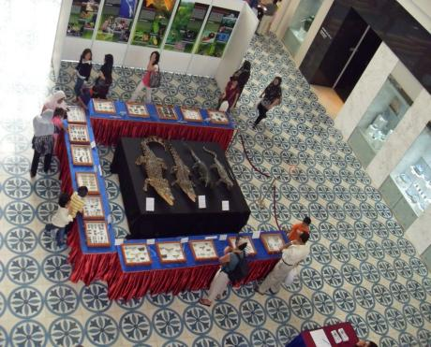

Source: XXX (2024)

A common use of Figures is to present graphs, photographs, or other illustrations (other than tables). The explanation of the Table should be after the Figure. All figures and tables should be cited in the main text as Figure 1, Table 1, etc.

Reference

Use APA style

Copyright

It is the author’s responsibility to ensure that his or her submitted works do not infringe any existing copyright. Furthermore, the author indemnifies the editors and publisher against any breach of such a warranty. Authors should obtain letters of permission to reproduce or adapt copyright material and enclose copies of these letters with the final version of the accepted manuscript.

Reference Citations

All entries in the reference list must be cited in text. Cite references in text using the author-date method [e.g., Sidek (1998)]. If a work has two authors, always cite both names every time the work is referred to in the text. If a work has three to five authors, cite all authors the first time the reference occurs; in subsequent citations, include only the name of the first author followed by “et al.” And the year whenever the work is cited (in the reference list, however, all names must be given). Page numbers should be provided when specific arguments or findings of authors are paraphrased, summarized, or directly quoted.

References List

An alphabetically-ordered reference list should be included at the end of the manuscript. All references cited in the text must appear in the reference list. Authors are responsible for the accuracy and completeness of all information in a reference. Several references by the same author(s) should be ordered chronologically (earliest date first). Begin the reference list on a new page and type the word REFERENCES centered at the top of the page. Type each entry using a hanging-indent format and follow the format and references style of the example below.