EXTENDED ABSTRACT HEADLINE

*(TIMES NEW ROMAN, 14 FONT SIZE, BOLD, ALL CAPS, CENTERED)*

Author’s Name and Surname1*, Author’s Name and Surname2 (11-pt, Times New Roman)  
1*Organization information that the author is affiliated with*  
2*Organization information that the author is affiliated with*\**Corresponding author’s email: [email@example.com]*

**ABSTRACT** (11 pt, Bold, All Caps, Centered)

The abstract should be no more than 300 words, written in Times New Roman, 11 pt, justified, with single line spacing. It should provide a concise summary of the objectives, methods, and findings of the study.

**Keywords:** Maximum of five words, written in Times New Roman, 11 pt, separated by semicolons.

# INTRODUCTION (Times New Roman, 12 pt, Bold, All Caps)

The extended abstract should follow a structured format and be more concise than the full paper. It must include the following sections: **Introduction, Literature Review, Method, Results and Discussion**, and **Conclusion**. The text should be in Times New Roman, 11 pt, single line spacing, and fully justified.

Extended abstracts may include figures, tables, formulas, or images. The content should effectively summarize the study, including its preparation phase. Page margins should be 2.5 cm on all sides (A4 size). Text should be fully justified without hyphenation. The extended abstract **should not exceed four pages**, including references.

British English should be used throughout. Abbreviations should be spelled out in full the first time they appear. Numbers ten and below should be written in words. Foreign language phrases should be italicized (e.g., Latin, French).

# LITERATURE REVIEW (Times New Roman, 12 pt, Bold, All Caps)

Relevant literature should be reviewed to identify research gaps and situate the current study in relation to prior research.

# Subtitle (Times New Roman, 11 pt, Bold, Title Case)

First-level headings (e.g., **2. LITERATURE REVIEW**) should be left-aligned, in all caps, and bold. Second- (e.g., **2.1. Subtitle**) and third-level (**2.1.1. Sub-subtitle**) subheadings should be left-aligned, bold, and in title case. A blank line should be inserted between paragraphs, with no paragraph indentation.

1. **METHOD** (Times New Roman, 12 pt, Bold, All Caps)

All materials and methods used in the study must be clearly stated. Subheadings should be used where necessary.

# RESULTS AND DISCUSSION (Times New Roman, 12 pt, Bold, All Caps)

**4.1. Subtitle** (Times New Roman, 11 pt, Bold, Title Case)

All tables, figures, and images should be centered. Figures and images should be numbered sequentially (e.g., **Figure 2**) with captions placed below them. Tables should also be numbered sequentially (e.g., **Table 2**) with headers placed above them. Table and figure captions should be bold, centered, and use uppercase initials.

References for tables, figures, and images should be cited directly below them in the format: (Author Surname, Year).

* 1. **Subtitle**

All of the tables, images and figures should be centered. Figures and images should be numbered together (Figure 2) and figure definitions should be placed under the figure or image; as for the tables, they should also be numbered (Table 2) and the table header should be placed at the top of the chart. Table, image and figure headers should be written with upper case initial letters, bold and should be centered. References (if any) of the tables, figures and images should be presented just under the tables, figures and images in the form of author surname and publication date.

|  |  |
| --- | --- |
| 2nd week | 3rd week |
|  |  |

# Subtitle

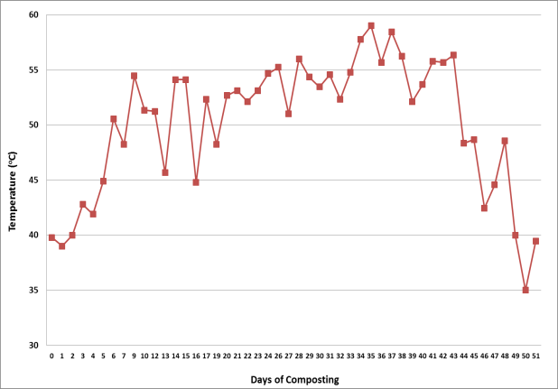

4th week 5th week

6th week 7th week 8th week

1st week

**Figure 2.** Figure Header

**Table 2.** Table Header

|  |  |  |  |
| --- | --- | --- | --- |
| Factor | Unit | Low | High |
| Final temperatures | °C | 200 | 600 |
| Heating rate | °C/min | 1 | 10 |
| Holding time | Min | 0 | 60 |
| N2 flow rate | L/min | 0.2 | 1.0 |
| Condensing temperature | °C | 0 | 10 |

*Reference: author surname and publication date (eg: George, 2009)*

# CONCLUSION (Times New Roman, 12 pt, Bold, All Caps)

The conclusion should summarize the most important findings of the study and suggest directions for future research.

# ACKNOWLEDGEMENT (Times New Roman, 12 pt, Bold, All Caps)

Acknowledge any research grants, organizations, or scholarships that supported the study, if applicable.

# REFERENCES (Times New Roman, 12 pt, Bold, All Caps)

Only references cited in the extended abstract should be listed. The reference list should follow the latest APA format.