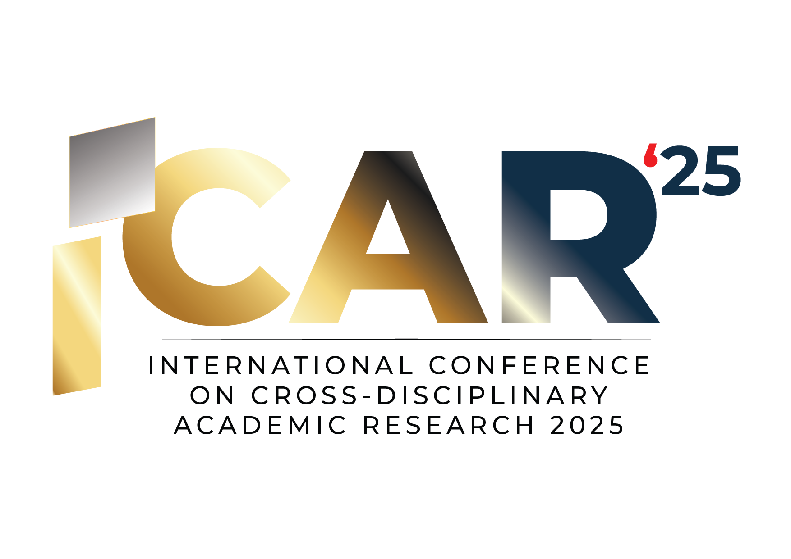

**THE 3rd INTERNATIONAL CONFERENCE OF CROSS-DISCIPLINARY   
ACADEMIC RESEARCH 2025 (ICAR2025)**

**CONSENT FORM (OPTIONAL)**

This form is intended for original, non-plagiarized and previously unpublished manuscripts submitted to The International Conference of Cross-Disciplinary Academic Research 2025 (ICAR25). The completed and signed form is necessary as a prerequisite for any publication or e-proceeding.

**Title of paper:**

**Author(s):**

**COPYRIGHT TRANSFER**

The undersigned hereby transfers all rights, including without limitation all copyrights, to ICAR 2025. The undersigned further represents and warrants that the paper is original and that they are the sole author, except for any material explicitly identified with its original source and accompanied by the necessary permission notices from the copyright owners, where required.

**GENERAL TERMS**

The undersigned certifies that they have the power and authority to prepare and submit this manuscript.

The undersigned agrees to indemnify and hold ICAR 2025 harmless from any damages or expenses arising from a breach of the warranties stated above.

If the manuscript is not accepted by ICAR 2025 or is withdrawn by the author(s) before acceptance, the copyright transfer will be null and void. However, ICAR 2025 will retain an archival copy of the manuscript.

For jointly authored works, at least one author must sign this agreement and confirm that they have obtained the consent of all co-authors, where applicable.

The undersigned grants ICAR 2025 the right to use materials contributed to the conference for educational and/or marketing purposes through web-based, digital, or print media.

The undersigned is responsible for communicating with the recommended journal regarding publication, including any processing charges.

_____________________________________

**Author's Signature:**

**Date :**

**University/ Institution:**