**FULL PAPER GUIDELINES**

**Instructions**

Authors are requested to submit the full paper **(Min 10 - Max 15 pages in the length including references)** in electronic form (MS-Word) via our Online Submission. Incorrect formatting may result in your paper being returned to you by email. The committee will select the manuscript for oral and poster presentations.

Generally, the full paper, should have:

1. Title
2. Authors *(Name, affiliation)*
3. Abstract
4. Introduction *(Research background/ Problem statement/ Research objectives/ Research question/ Hypothesis, etc)*
5. Literature Review
6. Methodology
7. Analysis
8. Conclusion *(Discussion/Recommendation)*
9. Acknowledgment
10. References

**Details**

1. **Title**

The title is type in Times New Roman; Title case, Size 20 points; Centred paragraph; 2 lines only

1. **Authors**

The authors should include their full names (with a maximum of 5 names), affiliations, and ensure the text is typed in Times New Roman, 10 pt, and centred. The lead presenter or corresponding author should be marked with an asterisk (*) and labelled as 'Lead presenter/Corresponding author.

1. **Abstract**

The abstract should not exceed **300 words**, typed in Times New Roman, 11 pt, regular font, and aligned justified. Keywords should include a **minimum of 3 and a maximum of 5.**

1. **Introduction**

The section may contain several subtopics such as Research Background, Problem Statement, Research Objectives, Research Questions, Hypotheses, and others as necessary

1. **Methodology**

This section should describe the methodology such as research process, instruments, data collection, etc.

1. **Analysis**

This section should discuss the analysis and result of the study and can include visualisation of data *(Graph, Charts, Diagram, Images, Tables, etc)*

**Figures & Tables**

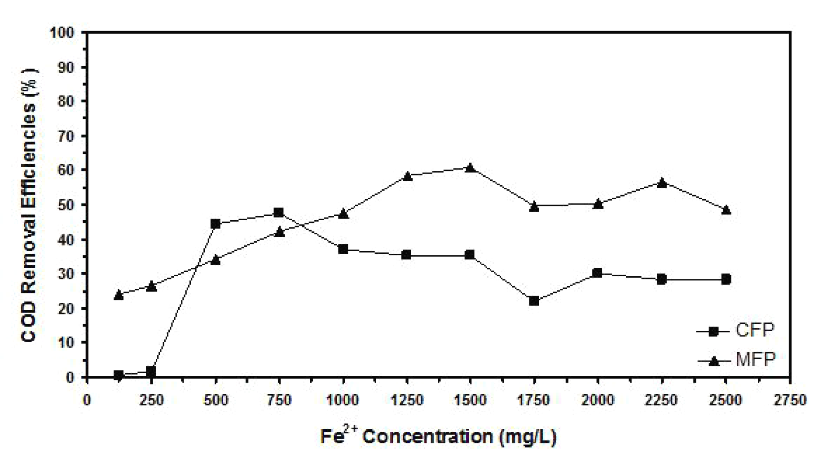

**Figure 1. Example of a figure caption.**

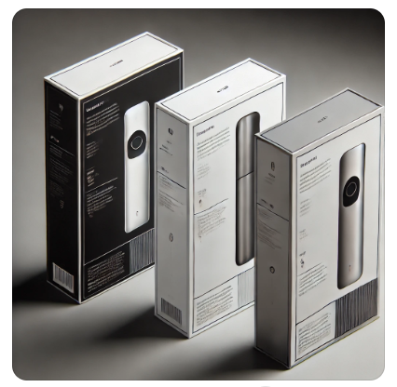

**Figure 2. Example of a figure caption.**

*(Source:xxxx)*

**Table 1. Example of a table caption**

| **No** | **Contents** |
| --- | --- |
|  |  |

1. **Conclusion**

This section should present the final outcome of the study and may include recommendations (if necessary) for future study.

1. **Acknowledgment**

The authors should acknowledge and express their gratitude for the support received from any sponsors or individuals who contributed to the study.

1. **References**

The references should be formatted in **APA 7th edition style** and limited to between **10 and 30 sources.** Type in Font Times New Roman, Text Normal, 11pt, Align Left

| ***Journal article*** | Geer, J., Hanraads, J. A. J. & Lupton R. A. (2000). The art of writing a scientific article. *Journal of Scientific Communications, 163*(1), 51-59. |
| --- | --- |
| ***Book publication*** | Strunk, W., Jr., & White, E. B. (1979). The elements of style. (3rd ed.). New York: Macmillan. |
| ***Newspaper article*** | Aulakh, R. (2012, June 13). From surviving to thriving. Toronto Star, GT1, GT4. |
| ***Online Newspaper article*** | Aw, J. (2012, June 12). Stopping the soda bulge: Why we need to consider restricting sugary beverages. National Post. https://nationalpost.com/health/stopping-the-soda-bulge-why-we-need-to-consider-restricting-sugary-beverages |
| ***Chapter in an edited book*** | Mettam, G. R., & Adams, L. B. (1994). How to prepare an electronic version of your article. In B. S. Jones, & R. Z. Smith (Eds.), Introduction to the electronic age (pp. 281-304). New York: E-Publishing Inc. |
| ***Web source*** | Smith, J. (1999, July 19). One of Volvo's core values. Volvo Cars UK. Retrieved August 19, 2023, from http://www.volvo.com/environment/index.htm |
| ***Journal article with Doi*** | Kennedy, A. K., Winter, V. R., & Corbin, M. M. (2019). Physical education class and body image perception: Are they related?. Physical Educator,76(2), 467-484.  https://doi.org/10.18666/tpe-2019-v76-i2-8766 |
| ***Local Malay author*** | Wan Mohd Dasuki Wan Hasbullah. (2018). Meor Abdul Rahman: Konsep Tempur Seni Gayong Dan Inovasi silat melayu. Jurnal Pengajian Melayu, 29(1), 262–285. https://doi.org/10.22452/jomas.vol29 no1.11 |

*Notes: Authors should ensure that all references are from reliable sources and avoid using predatory journals (e.g., MDPI, Frontiers Media, WASET) and unreliable sources such as Wikipedia, personal blogs, and similar platforms.*